ENME 304 Machine Design

Design Update 1

Professor Janelle Clark

10/01/25

Group 10 Members-

Adam Beall

Bilal Faizullah

Ian Wright

John Xavier

Ideas:

* Rack lift
* Scissor lift
* Screw lift

Possible Parts Suppliers:

* McMaster-Carr: All
* Home Depot: Fastening
* Motion industries: Power Transmission
* Gates: Power Transmission
* Global Industries
* MSC Industrial: Fasteners
* Fastenal: Bearings/Pulleys
* AIS Industrial: Gears/Fasteners
* PBC Linear: All
* Misumi: All

Possible Custom Parts Suppliers:

* Loper Machine: CNC Machining (Especially Aluminum)
* UMBC Machine Shop: DNC Machine Shop
* Innovation Lab: 3D Printing

Project Timeline and Gantt Chart:

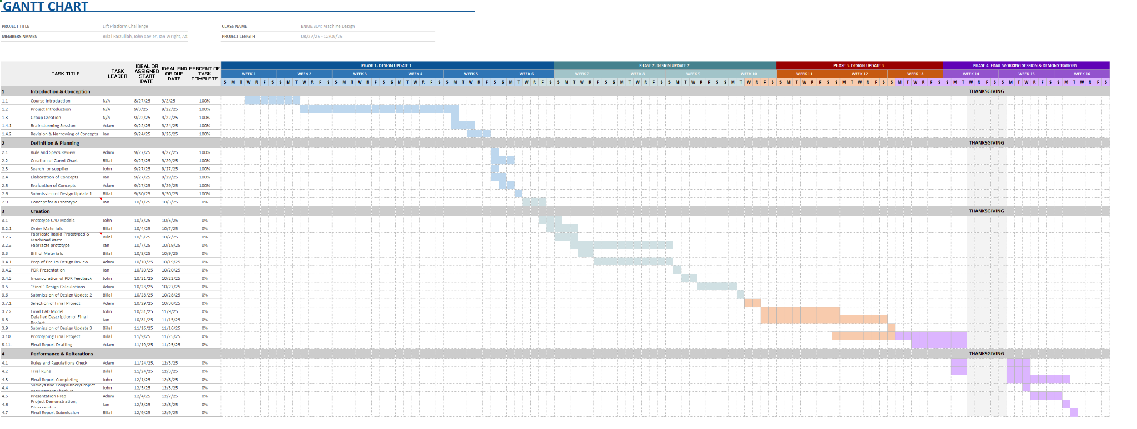

Figure 1: Gantt Chart (Entirety)

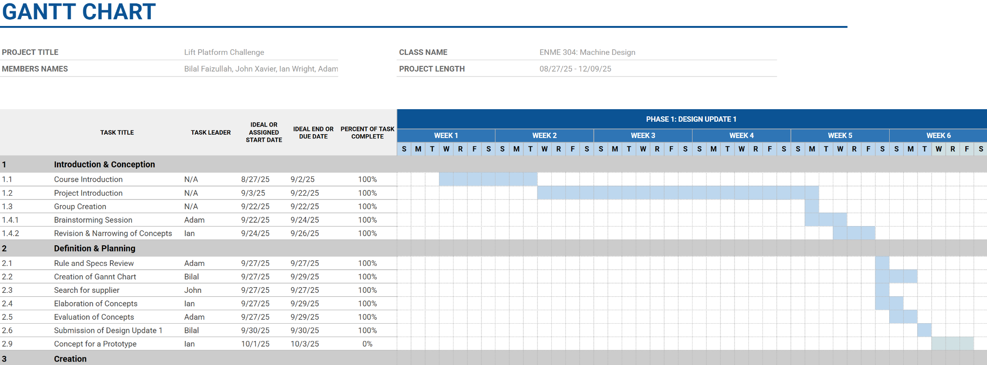

Figure 2: Gantt Chart (First Third)

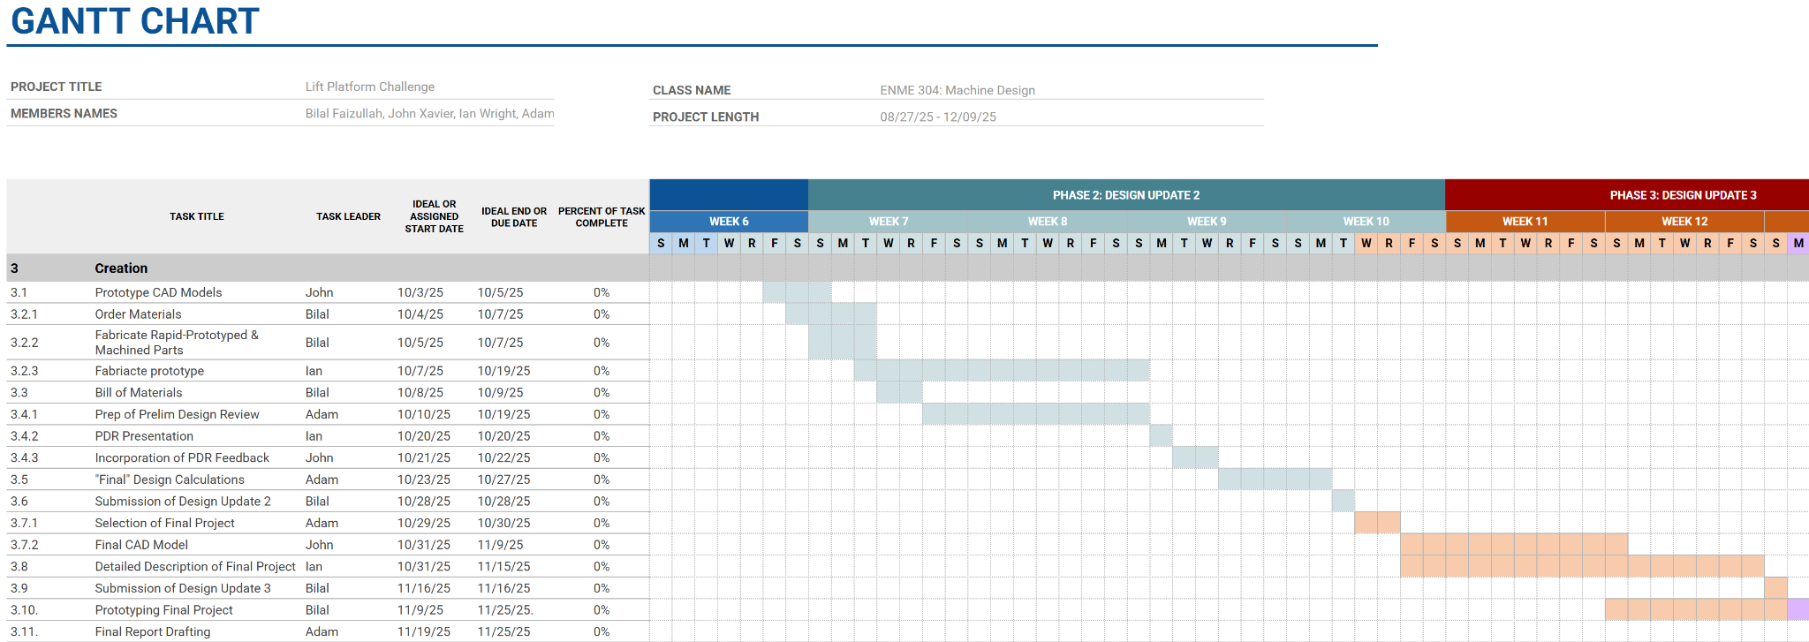

Figure 3: Gantt Chart (Second Third)

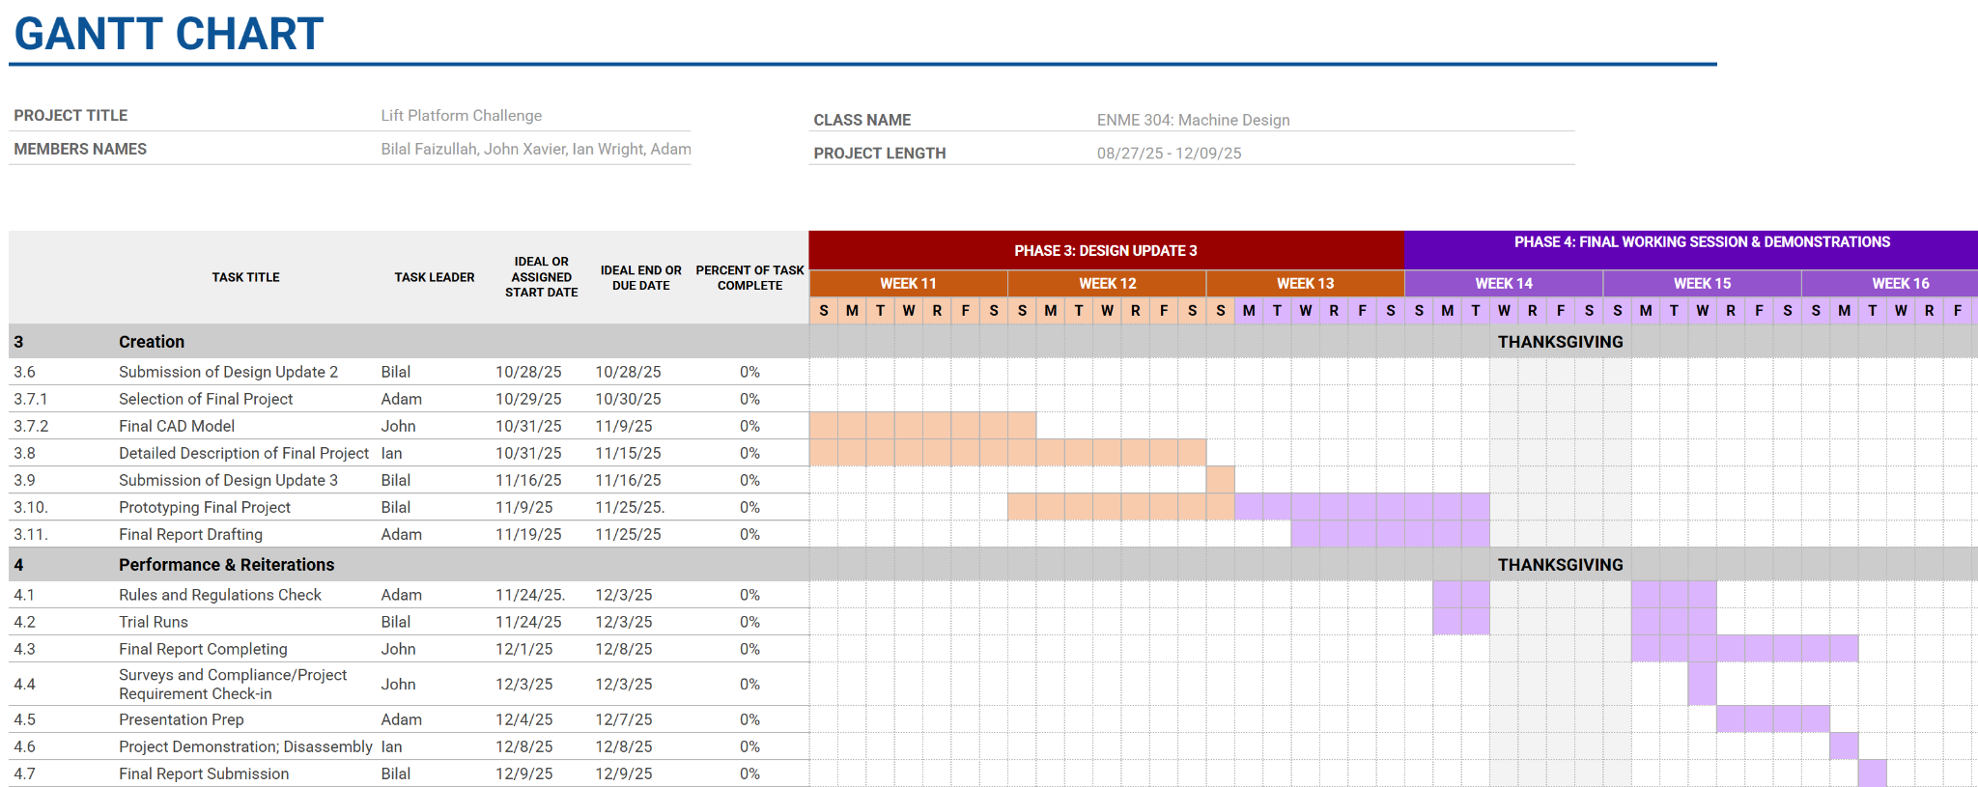

Figure 4: (Final Third)

Material Orders/Needs and Challenges

Currently we are going through the challenge of trying to narrow down our ideas to a few plausible ideas so we are currently weighing the options of each. Due to this we are not making any material purchasing decisions yet.

Primary Design Ideas

For all of our Designs they have to abide by certain Input constraints, output requirements, and drivetrain fits and loads. For all of these Designs they must follow these basic conditions. The final system must fit in an 8x8x8” box, it needs to lift a 3.2lb or for extra points a 5lb Bucket of lead and the final height of the Bucket must be 12” no matter if the starting height was below the maximum allowed 8” height.

Our First idea was to use a Scissor lift, a scissor lift is a criss cross support system that can collapse down on itself and its support arms to provide vertical load support at adjustable heights. Scissor lifts are useful systems that translate lateral motion to vertical motion but you often have to trade maximum lateral movement for maximum allowable vertical movement and vice versa. There are some Scissor lift systems that can amplify the distance but it comes at the cost of the required force to move the system. We are considering using a gear train of 4 gears to amplify the power of the motor which is then connected to a spool. It will include a set of spur gears attached to the motor with Bevel gears attached to the shaft of the second spur gear. The spool is then connected to the Bevel gear and the string attached to the spool connects to the ends of the scissor lift allowing us to wind it in and out to control the Scissor lift going up or down.

Scissor Lift Force Calculations-

Assuming no friction is in the system, energy isn't lost to the environment, scissor lift and top plate weight 3 lb

Rated load torque- 380.3 g-cm = Tr

Required Force to Lift- 5lb or 5760.62g-cm = Wb

Required Force to Lift Weight of Scissor arms and Top Plate- 3lb or 3456.4g-cm = Ws

Required Force Motor needs to lift - 8lb or 9217.02g-cm = Wt

$Ratio Required to Lift Bucket = \frac{Wb}{Tr} = \frac{5760.62}{380.3} = 15.15$

$Ratio Required to Lift Bucket and System Components = \frac{Wt}{Tr} = \frac{9217.02}{380.3} = 24.24$

To lift the required 5lb load we will need a gear ratio of at least 15.15 but since the motor will also be lifting the arms of the scissor lift and top plate that the bucket will be on, we will need to increase the ratio to 24.24:1 In order to lift the bucket. We will set it up to a 30:1 gear ratio however to ensure it has enough force to lift the bucket plus any other forces we may not have considered.

$GR=\frac{Ng}{Np}$

We will also set the number of teeth of the Pinion gear to 16 and this will allow us to find the required number of teeth to achieve both gear ratios.

$10 = \frac{Ng1}{16}$ $Ng = 10(16) =160 Teeth on normal gear$

First bevel gear on shaft with final Spur gear so they move at the same rate so the Bevel gears will amplify the previous torque

$3 = \frac{Ng2}{16}$ $Ng2 = 16(3) = 48 Teeth on Second Bevel Gear$

The ratio of 10:1 then a ratio of 3:1 gives us a final Gear Ratio of 30:1.This should allow us to achieve the necessary torque with a gear train of just 4 gears and a gear ratio of 30:1.

$Torque Produced by Gear Train = 30(Tr) = 30(380.3) = 11409g-cm$

Estimated load Torque produced- 11409g-cm or 9.903 lb-inch

e = 0.0127, if 𝟂o = 50.27 RPM, (string V = 0.133 in/s) -> To = 25.6 lbf-in

Also, bevel gears are very expensive

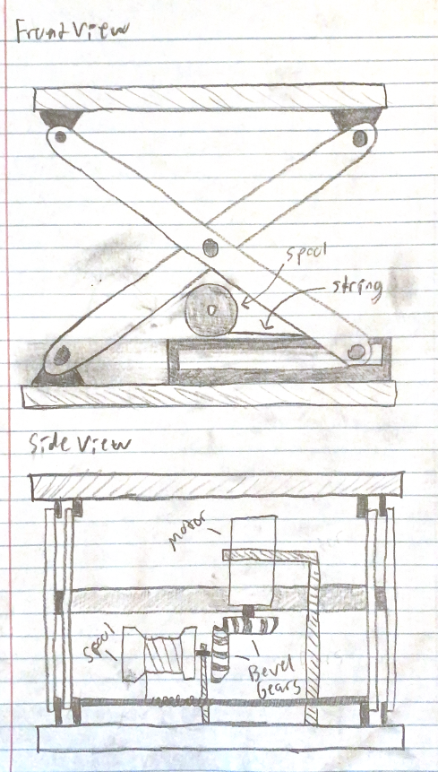

Figure 5: Scissor Lift Sketch

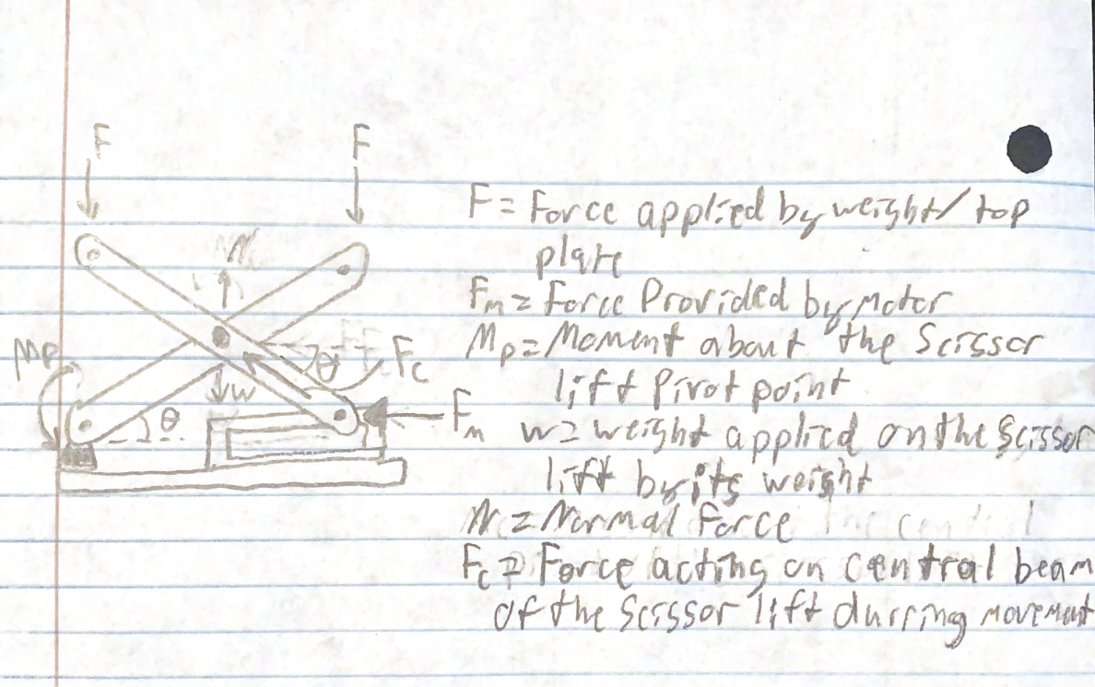

Figure 6: Scissor Lift FBD Under Load and Operation

The second design concept was a screw lift mechanism, chosen for its controlled linear motion. The system was designed around a worm spur gear drive, where a worm gear is attached to the motor shaft which engages with a spur gear with a screw threaded on the inside. As the motor rotates the worm, it drives the spur gear, causing the screw to rotate. This rotation is converted into linear travel by a nut threaded on the inside of the spur gear, raising or lowering the lifting platform.

*Calculations*

The force required for the screw lift to lift

$F = 5lb*32.7ft=163.5 lbf$

The torque of the motor(380.3 g*cm) converted to lb*ft

$T_{motor}=\frac{.3299}{12}=.027 lb*ft$

The assumed average diameter of the screw

$d_{m}=\frac{1.42}{12}=.118ft$

The coefficient of friction for an aluminum bar [1]

$f=.4$

Calculating the torque required to spin the screw to lift 5 lbs

$T_{R}=\frac{(F*d_{m})}{2}(\frac{(f * d_{m} * π) - l}{(d_{m}* π) + (f * l)})=\frac{(163.5 * .118)}{2}(\frac{(.4 *.118 * π) - .75}{(.118* π) + (.4 * .75)})=121.16 lb*ft$

Calculating the gear ratio and converting it to a fraction

$Gear Ratio =\frac{T_{motor}}{T_{R}}=\frac{.027}{121.16}=\frac{1}{4407.14}$

The gear ratio is 1:4407 which would require a multi-stage gear box to support the load due to the motor restraints that would not be feasible for this design. The multi-stage gear box would cost more than what it would be worth to gather the parts and would likely take more time than the allotted two minutes to lift the weight. Due to these factors, there is no reason to continue calculations as this design is not a feasible option.

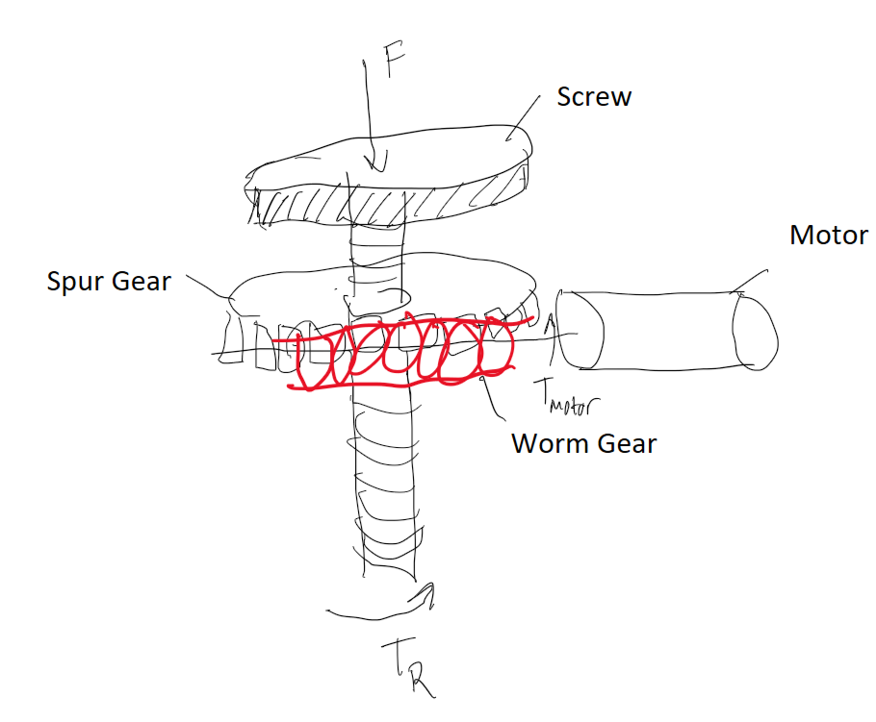

Figure 7: Free Body Diagram for the screw lift

Our third idea was the rack lift. This concept uses a pinion gear to power a rack gear. This rack gear will be attached to legs connected to the bottom of the platform. When the gear spins, the rack goes up, lifting the platform with it. This system will run using a compact gear train that can fit inside an 8x8x8 inch box. The gear train will run from a small pinion on the motor to a small rack pinion per leg. There will be 4 legs total, each will be powered by a pinion. The motor will spin a small spur gear that powers a large spur gear. This gear is part of 2 compound trains of helical gears, both the same diametric pitch. The helix gear on the left is a right hand gear, while the gear on the right is a left hand gear. Every component from these gears will be identical. The helix gear will connect to a larger helix gear that is on the shaft of 2 spur gears connected to small spur gear pinions to improve speed and lessen torque from the platform. Then these connect to the spur rack gears. In total, there will be 12 gears total.

Rack Lift Calculations:

Assuming no friction, loss of power, rated loads,

Force lifted: W = 8lb

Input Torque: T = 380.3 g-cm = 0.33lbf-in

Input Angular Velocity: ωi = 3950 RPM

Minimum teeth: $NL=$ 18

Assume: Uniform load, no friction, no energy lost, 100% efficiency

The object is 5lb, but I made it 8lb to consider the platform weight. To lift 8lb, the torque of the last gear must be calculated:

$To = W\frac{do}{2}$

The gear must have 18 teeth, so I will make dL = 0.5 inches for now, resulting in T = 4 lbf-in. To find output angular velocity:

$ωo =\frac{Tiωi}{To}=\frac{0.33(3950)}{4}=325.88 RPM$

To calculate e:

$e=\frac{ωo}{ωi}=\frac{325.88}{3950}=0.083$

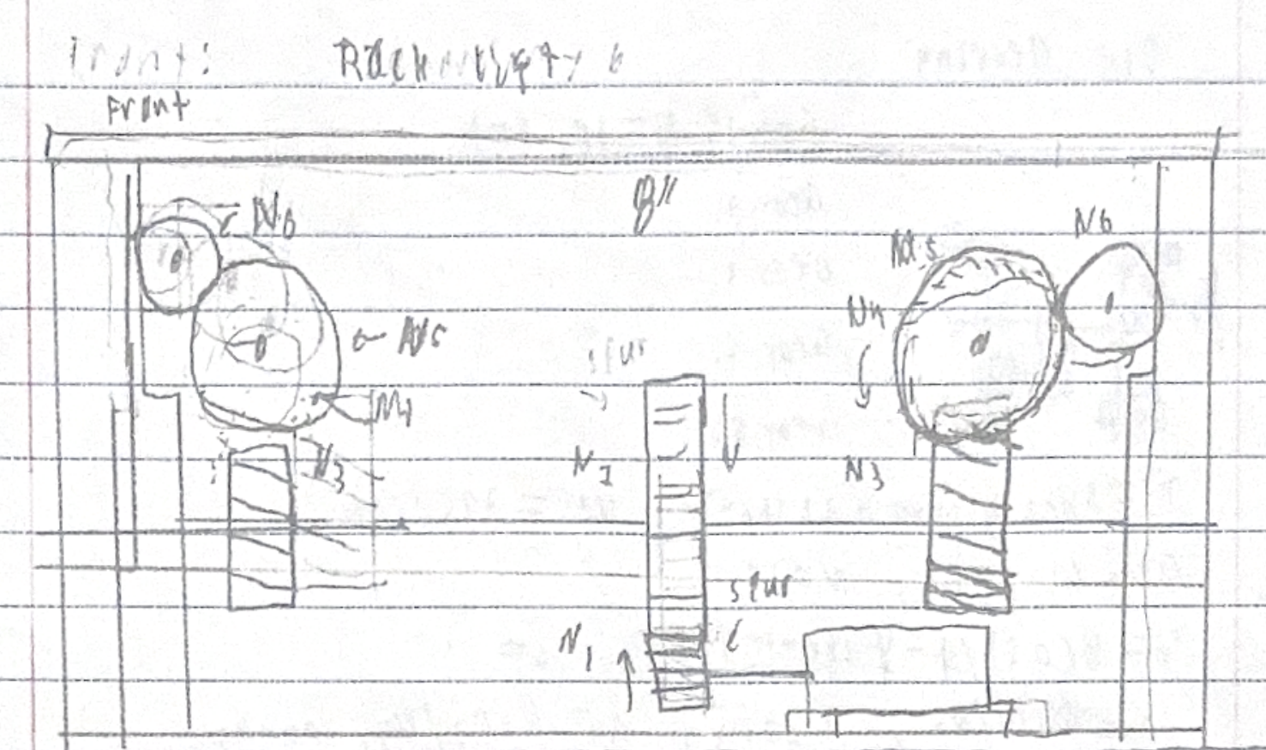

Figure 8: Racklift Free Body Diagram and Sketch

Teams Final Design Choice-

Through our Group’s Brainstorming we came to the conclusion that out of all 3 of our proposed ideas the Scissor lift would be the most efficient and practical design we could pursue. Let's address how we came to this conclusion from the strengths and weaknesses of the other systems.

The Screw Lift is the worst of the 3 systems. This is due to it providing lift to one screw, causing excess stress on one component. With the design requirements having us lift a 3.1-5lb bucket there is simply too much strain on this system to make the system possible to build and work for the allotted time.

Unfortunately The Rack Lift didn't make the cut either but it does have a practical strength, that is the Rack Lifts ability to have precise control over gear movements. This comes from the sandwiched gear design that allows for no gear slip or unalignment before failure. This runs into some of the same problems the screw lift had, primarily the space requirements. This is because the rack lift will need to have 4 rack lift systems on each corner of the design taking up a large portion of our internal space. Along with this our gear train will require 12 total gears to provide power to the rack lifts so this will require a large area which might not be possible to fit in our 8x8x8” requirement.

With all of this in mind we determined that the Scissor Lift was the best choice for our design parameters. It provides a simple system that can be easily sized up or down based on size constraints, it maintains vast amounts of internal area even under operation, it is a mechanically simple system with fewer moving parts so less to go out of alignment or break, and the gear train will be very simple at just 2 gears.

Work Cited-

[1] *Friction Coefficients*. [Online]. Available: [Friction - Coefficients for Common Materials and Surfaces](https://www.engineeringtoolbox.com/friction-coefficients-d_778.html). [Accessed: Oct. 27, 2023].